MLOps: An Enterprise Approach to Machine Learning Deployment and Management

Aiswarya Kattappilly Ravi
Computer Science dept.
Liverpool John Moores University
Liverpool,United Kingdom
csmakatt@ljmu.ac.uk

Abstract— The deployment and management of machine learning systems at scale are the main topics of this article, which focuses on the MLOps' escalating significance in the enterprise setting. While data scientists have historically concentrated on creating ML models alone, a DevOps approach to ML pipelines has gained popularity in recent years. Due to this, MLOps frameworks have been created, which offer complete production pipelines and lifecycles. These frameworks rely on a variety of components, including DL/ML libraries, Docker, and Kubernetes.
Designing an object detection system that makes use of a scalable model server with GPU support to host an object detection model and provide a web interface for uploading images and providing the result is the challenge of this research. The suggested system will make use of the pre-existing TensorFlow 2 Object identification model from the model zoo. To enable rapid and effective model deployment, monitoring, and version control, the architecture will use MLOps principles. To facilitate simple deployment and scaling, the suggested framework will make use of containerization options for the web application, model server, and support code. In order to guarantee that trained models can be rolled back and replaced without causing any disturbance, the design will also incorporate an infrastructure test plan.
Keywords—MLOPs, Docker, Kubernetes.

Introduction
The paper is designed to equip learners with the skills and knowledge necessary to deploy and manage frozen machine learning models in an enterprise setting. This involves using tools and frameworks that support MLOps, which is a DevOps approach to machine learning pipelines. In the past, data scientists developed machine learning solutions in isolation, without considering how they would be deployed and managed at scale. However, as machine learning has matured over the last five years, there has been a shift towards applying a DevOps approach to machine learning pipelines, which is now referred to as MLOps. MLOps frameworks rely on important components such as deep learning/machine learning libraries used to train the model, and Docker and Kubernetes to provide an end-to-end production pipeline and lifecycle. This report will analyse the benefits, technologies, and frameworks that support enterprise model deployment and management. The analysis will provide insights into how enterprises can leverage MLOps to streamline their machine learning workflows, increase efficiency, and reduce costs.
The report will explore various MLOps frameworks and tools available, such as TensorFlow Extended, Kubeflow, and MLflow, and their respective strengths and weaknesses. It will also examine the benefits of using MLOps in enterprise settings, such as automating repetitive tasks, improving model deployment speed, and enhancing model accuracy.
Overall, the report aims to provide a comprehensive analysis of MLOps, its benefits, and the tools and frameworks available to support enterprise machine learning model deployment and management. The insights and recommendations provided in the report can help enterprises optimize their machine learning workflows and achieve better business outcomes [1].

Background
Machine Learning Operations (MLOps) is a revolutionary set of practices and technologies that bring DevOps principles to machine learning workflows. Its primary objective is to streamline the development, deployment, and maintenance of machine learning models in production environments. MLOps aims to create an end-to-end pipeline that encompasses the entire machine learning process, from data preparation to model training, deployment, and monitoring.
The benefits of MLOps are numerous and include increased efficiency, faster time to market, better model accuracy, and reduced risk. By adopting MLOps practices, data scientists can collaborate more effectively with developers and IT operations teams, resulting in faster deployment of machine learning models to production environments. MLOps also promotes the use of automation, reducing the risk of human error and allowing for more consistent and reproducible model performance. However, MLOps also presents some challenges. The biggest challenge is the complexity of the machine learning workflow, which involves many different stages and requires collaboration between multiple teams with different skill sets. Another challenge is the need for effective data management, including data versioning, metadata management, and data lineage tracking.
Despite these challenges, MLOps has evolved significantly over the last few years, with the emergence of new tools and frameworks that support the end-to-end machine learning pipeline. Critical underpinning technologies include machine learning and deep learning frameworks such as TensorFlow, PyTorch, and Keras, as well as containerization technologies such as Docker and Kubernetes. The MLOps workflow typically involves several stages, including data preparation, model training, model testing, model deployment, and monitoring. MLOps toolchains are used to automate and streamline these stages, with tools such as DVC, MLflow, and Kubeflow providing end-to-end machine learning pipelines. There are numerous MLOps frameworks available, both commercial and open source, that can help organizations streamline their machine learning workflows. Some of the popular commercial offerings include Amazon SageMaker, Microsoft Azure Machine Learning, and Google Cloud AI Platform. On the other hand, open-source options like Kubeflow, MLflow, and TensorFlow Extended are also gaining traction. Choosing the right MLOps framework depends on various factors, such as the size of the team, the complexity of the machine learning workflow, and the available resources. It is crucial to evaluate each option carefully and select the one that aligns with the organization's specific needs [2][3].
One of the critical aspects of the MLOps workflow is productionalization, which involves automating the deployment and management of machine learning models in production environments. End-to-end pipelines are used to achieve this, and automatic pipelines are becoming increasingly popular due to their efficiency and consistency. In contrast, manual ML cycles are prone to errors and require more manual intervention. Another essential component of the MLOps workflow is feature stores, which provide a centralized repository for machine learning features that can be reused across different models. Feature stores promote consistency and reduce the risk of data inconsistencies, enabling data scientists to focus on model development rather than data preparation. They also facilitate better collaboration between data scientists and software engineers by providing a common interface for feature extraction and engineering.
MLOps is a game-changer in the world of machine learning. It offers numerous benefits, including increased efficiency, faster time to market, better model accuracy, and reduced risk. While it presents. Selecting the right MLOps framework and implementing productionalization and feature stores are crucial steps in streamlining the machine learning workflow and achieving better collaboration between data scientists and software engineers.

Consideration
MLOps is a cutting-edge methodology that applies the principles of DevOps to the development, deployment, and maintenance of machine learning (ML) models. Its primary objective is to streamline the ML workflow and enhance the efficiency of the model lifecycle by integrating automation, collaboration, and monitoring tools into the process. By doing so, MLOps enables faster, more reliable, and more scalable deployment of ML models.
In simpler terms, MLOps is a set of practices that help data scientists and developers work together seamlessly to create and deploy ML models. It involves automating the entire ML workflow, from data preparation to model training and deployment, to ensure that the process is efficient and error-free. Collaboration is also a key aspect of MLOps, as it encourages cross-functional teams to work together and share knowledge and expertise. Moreover, MLOps provides a robust monitoring system that enables teams to track the performance of their ML models in real-time. This allows them to identify and address any issues promptly, ensuring that the models are always running smoothly. With MLOps, organizations can achieve faster time-to-market, reduce costs, and improve the overall quality of their ML models [4].

MLOps: Benefits, Challenges, Evolutions, and Underpinning Technologies
MLOps, or Machine Learning Operations, is a set of practices and technologies that aim to streamline the development, deployment, and management of machine learning models. MLOps has gained significant traction in recent years, as more organizations seek to leverage the power of machine learning to gain a competitive edge. In this article, I will explore the benefits, challenges, evolutions, and underpinning technologies of MLOps.

Benefits
The benefits of MLOps are numerous and significant. They include [5]:
- Increased speed of model development and deployment: MLOps enables data scientists to develop and deploy models faster, thanks to automation and collaboration tools.
- Improved accuracy and reliability of models: MLOps helps data scientists to build more accurate and reliable models by providing better data governance, version control, and testing.
- Better collaboration between data scientists, developers, and operations teams: MLOps fosters better collaboration between different teams involved in the ML workflow, leading to more efficient and effective model development and deployment.
- Greater scalability of models: MLOps enables organizations to scale their ML models easily and efficiently, thanks to containerization and cloud-based platforms.
- Better governance and regulatory compliance: MLOps provide better governance and regulatory compliance by ensuring that models are developed and deployed in a secure and transparent manner.

Challenges
Despite its many benefits, MLOps faces several challenges, including [6][7]:
- Complexity of the ML workflow: The ML workflow is complex and involves many different tools and processes, making it challenging to manage and optimize.
- Difficulty in integrating various tools and platforms: MLOps requires the integration of various tools and platforms, which can be difficult and time-consuming.
- Lack of standardized tools and processes: MLOps lacks standardized tools and processes, making it challenging to develop and deploy models consistently across different teams and organizations.
- Difficulty in managing data and model versions: MLOps requires

efficiency
MLOps, or Machine Learning Operations, has undergone significant changes and advancements to improve its effectiveness, efficiency, and scalability. Let's explore some of the key evolutions of MLOps.
- One of the most significant changes has been the adoption of DevOps principles in the ML workflow. This approach emphasizes collaboration and communication between different teams involved in the ML process, such as data scientists, developers, and operations professionals. By integrating DevOps principles, MLOps has improved the efficiency and quality of the ML workflow.
- Another evolution of MLOps is the integration of automation and monitoring tools. These tools help data scientists and operations teams work more efficiently by detecting and fixing issues early in the process, saving time and resources. Automated testing and monitoring tools are particularly useful in this regard.
- Finally, containerization technologies such as Docker and Kubernetes have been used to make machine learning models more portable and scalable. Docker allows developers to package applications and their dependencies into containers that can run anywhere, while Kubernetes can manage and deploy containerized applications at scale. These technologies enable data scientists to create models that can be easily deployed and scaled in different environments.
- The emergence of feature stores has revolutionized the way data scientists manage and share data features across different teams and departments within an organization. These data management platforms enable data scientists to create, manage, and share features, ensuring that everyone is using the same features, which can significantly improve the consistency and accuracy of machine learning models.
- Moreover, cloud-based machine learning platforms have gained immense popularity in recent years, offering end-to-end machine learning pipelines that can handle everything from data preparation to model deployment. These platforms have made it easier for data scientists to create and deploy models without worrying about managing the underlying infrastructure. With cloud-based platforms, scalability and flexibility are at the forefront, as resources can be easily added or removed as needed.

Underpinning Technologies in MLOps
Machine Learning (ML) and Deep Learning (DL) frameworks, Docker, and Kubernetes are essential technologies that form the foundation of MLOps.
- ML/DL frameworks offer a wide range of tools and libraries that are necessary for building and training ML models. Some of the most popular frameworks include TensorFlow, PyTorch, and scikit-learn.
- Docker is a containerization technology that enables models to be packaged with their dependencies, making them easily portable across different environments. This feature is particularly useful in MLOps, where models need to be deployed and tested in various environments.
- Kubernetes is an open-source platform that simplifies the management of containerized applications. It automates the deployment, scaling, and management of containerized applications, making it an ideal technology for MLOps.
By leveraging these underpinning technologies, MLOps teams can streamline their workflows, reduce errors, and improve the overall efficiency of their ML models. These technologies are critical for organizations that want to stay ahead of the curve in the rapidly evolving field of machine learning [8].
Design, model deployment, and operations are only a few of the processes that make up the MLOps workflow. The process is facilitated by MLOps toolchains, which are often made up of a mix of open-source and paid technologies that support the whole machine learning lifecycle.

Design
Data scientists and engineers collaborate during the design stage to create a machine learning model. They start by defining the issue, choosing the pertinent data sets, and choosing the variables that will be employed in the model's training. The team then analyses the data using data exploration techniques to spot trends and linkages. ML frameworks like TensorFlow, PyTorch, and scikit-learn are used to train and evaluate the model after it has been created.

Model Deployment
The trained model is put into a production environment during the model deployment step. This entails utilizing Docker or other containerization technologies to package the model and any related dependencies inside a container. A Kubernetes cluster can then be used to deploy the container, giving the model a scalable and portable environment.

Operations
The deployed model is checked for defects and performance at this step. This entails gathering and studying input, output, and log data from the model. To guarantee that the model keeps working properly, any problems or defects are swiftly found and fixed.
The full machine learning lifecycle, from data preparation and exploration through model training and deployment, is supported by MLOps toolchains. These toolchains contain a variety of instruments and frameworks, including:
- Data Exploration: Data exploration and analysis are done using programs like Pandas, NumPy, and Matplotlib.
- ML Frameworks: Building and training machine learning models is done using frameworks like TensorFlow, PyTorch, and scikit-learn.
- Tools for containerization: Models and dependencies are packaged into containers using Docker, while Kubernetes provides a platform for large-scale container deployment and management.
- Monitoring Tools: Performance information is gathered and monitored for the deployed models using tools like Prometheus and Grafana.
Organizations may speed up the creation and deployment of machine learning models while ensuring that they are dependable and scalable in a production setting by utilizing these technologies and adhering to the MLOps workflow.

Available MLOps frameworks and a comparison between commercial and opensource offerings.
Many MLOps frameworks, both open-source and for-profit, are on the market to facilitate the deployment and maintenance of machine learning models. Among of the well-liked MLOps frameworks are [9][10]:

An open-source machine learning platform based on Kubernetes is called Kubeflow. It offers resources for model training, model deployment, and data preprocessing.
- An open-source platform called MLflow is used to handle the entire machine learning lifecycle. It enables tracking of experiments, reproducible code packaging, sharing, and deployment of models.
- TensorFlow Extended (TFX): TFX is an end-to-end platform for deploying machine learning models that are prepared for production use. It has elements for serving model training, preprocessing, and data validation.
- H2O.ai is an open-source machine learning platform that provides a variety of tools for creating and deploying machine learning models. It features a simple graphical user interface and supports many machine learning techniques.
- Amazon SageMaker is a cloud-based platform that offers tools for creating, honing, and deploying large-scale machine learning models. For simple deployment, it provides pre-built notebooks, algorithms, and APIs.
- Microsoft Azure Machine Learning: A cloud-based platform that offers tools for creating, honing, and deploying machine learning models is known as Microsoft Azure Machine Learning. It has attributes like model explain ability and automated machine learning.
- Google Cloud AI Platform: In the Google Cloud Platform, Google Cloud AI Platform offers tools for creating, deploying, and managing machine learning models. It supports interfaces with other Google Cloud services as well as support for a number of machine learning frameworks.
There are many MLOps frameworks on the market, both for sale and free. Here are some significant variations between for-profit and free software:
- Cost: While open-source alternatives are normally free to use, commercial MLOps frameworks are typically pricey and require recurring subscription costs.
- Open-source MLOps frameworks are more customizable because users have access to and control over the source code. Commercial frameworks, on the other hand, offer less customization options.
- Support: While open-source MLOps frameworks rely on community assistance, commercial MLOps frameworks often include specialized customer support and maintenance services.
- Features: While open-source alternatives may need more setup and configuration to obtain the same level of usefulness, commercial MLOps frameworks typically offer more features and functions out-of-the-box.
- Security: Due to their open nature, commercial MLOps frameworks frequently have more stringent security controls and certifications in place than open-source alternatives.
The decision between an open-source and a commercial MLOps framework ultimately comes down to the needs, capabilities, and goals of the organization.

A discussion of productionalisation (end-to-end pipelines) and a comparison between manual
Productionalization is the process of taking a machine learning model that has been trained and putting it into a real-world setting where it can be used to predict outcomes from fresh data. Preprocessing, model training, validation, deployment, and monitoring are just a few of the processes that make up the process. Productionalization can be done manually or using an automation pipeline. Manual ML cycles require human input at every stage of the procedure. This method involves manually preprocessing the data, training the model, and deploying it in a real-world setting. The manual procedure can take a long time and be error prone. In addition, especially when working with huge datasets, it can be difficult to replicate the same results in the future.
Automatic pipelines, in contrast, use MLOps frameworks to fully automate the productionalization process. With this method, the framework handles preprocessing, training, validation, deployment, and monitoring while data scientists provide the workflow for their ML models. Some advantages of automatic pipelines over manual ML cycles include:
- Efficiency: Automated pipelines can hasten the productionalization procedure and speed up the deployment of machine learning models into the production environment.
- Consistency: Automated pipelines make sure the same procedure is followed each time a new model is deployed, lowering the possibility of mistakes and inconsistencies.
- Scalability: It is simpler to deploy ML models in production since automatic pipelines can scale to accommodate huge datasets and complex models.
- Reproducibility: Even when using massive datasets, data scientists can reliably recreate the same conclusions thanks to automatic workflows.
In general, autonomous pipelines are a more effective and dependable method of productionalization, particularly when handling huge datasets and intricate models.

Feature stores including their roles and benefits within the ML pipeline.
For use in machine learning (ML) models, preprocessed and feature-engineered data are kept in a feature store, a central repository. By standardizing the process of creating, storing, and retrieving features for ML models, feature stores offer an answer to the problem of feature management.
In order to effectively reuse and share features across many models, teams, and projects, feature stores play a crucial role in the ML pipeline. By offering a unified platform for feature engineering and administration, they also enhance collaboration between data scientists, engineers, and other stakeholders.
Using feature stores has the following advantages:
- Feature stores give data scientists access to high-quality, preprocessed features that are constant across projects, helping them to create models that are more accurate.
- Faster model development: Feature stores speed up the model building process by lowering the time needed for data preprocessing and feature engineering by offering a central location for storing and exchanging features.
- Feature stores offer a transparent record of feature engineering efforts, making it easy to manage changes, validate outcomes, and guarantee regulatory compliance. This improves model governance and repeatability.
- Less danger of technical debt and simpler model updating as data changes thanks to feature stores that let data scientists build and maintain features independently of the models that use them.
- Scalability and adaptability: Feature stores may be flexible for a variety of use cases and scalable to handle enormous volumes of data. They can also be connected with different ML frameworks and data storage solutions.
Overall, by offering a central location for controlling, storing, and exchanging features, feature stores play a crucial role in facilitating effective and efficient ML model development and deployment.

Methodology
The objective of this paper is to develop an efficient object detection system by utilizing a pre-existing TensorFlow 2 Object detection model from the model zoo. The system must be scalable, GPU-supported, and equipped with a user-friendly web interface for uploading images and obtaining results. This requirements specification will consider MLOps principles and their relevance to the problem at hand. My primary aim is to create a robust and reliable object detection system that can accurately identify objects in images. To achieve this, I will leverage the power of TensorFlow 2, a cutting-edge machine learning framework that offers advanced features for developing high-performance models. By utilizing a pre-existing model from the model zoo, I can save time and resources while still achieving our desired results.
In addition to accuracy, scalability is a crucial factor in the success of any machine learning system. My system must be capable of handling large volumes of data and processing it efficiently. To accomplish this, I will incorporate GPU support, which will significantly enhance the system's performance and speed. Furthermore, I recognize the importance of providing a user-friendly interface for our system. Therefore, I will develop a web-based interface that allows users to upload images and receive results quickly and easily. This interface will be intuitive and straightforward, ensuring that users can interact with the system without any technical expertise.
Finally, I will consider MLOps principles throughout the development process. MLOps is a set of best practices for managing machine learning projects, including version control, testing, and deployment. By adhering to these principles, I can ensure that our system is reliable, maintainable, and scalable. When designing an object detection system that utilizes a scalable model server with GPU support, it is crucial to consider MLOps principles to ensure that the system is efficient, scalable, and easy to maintain. Here are some of the requirements that should be considered:
- Infrastructure: The system must be deployed on a scalable infrastructure that can handle the load and can easily scale up or down as needed. GPU support is necessary to accelerate the processing of images and improve the speed of inference.
- Model Selection: The selected model should be well-suited for the task at hand and should have a high level of accuracy. In this case, the pre-existing TensorFlow 2 Object detection model from the model zoo can be used.
- Training and Validation: The model should be trained on a diverse set of images to ensure that it can accurately detect objects under different lighting conditions, angles, and perspectives. Validation of the model's accuracy should also be performed to ensure that it meets the desired performance metrics.
- Model Deployment: The model should be deployed on a scalable model server that can handle incoming requests and provide fast and efficient inference. Docker containers can be used to encapsulate the model and its dependencies, allowing for easy deployment and management.
- Web Interface: A user-friendly web interface should be designed to allow users to upload images and receive object detection results. The interface should have clear instructions on how to upload images and view the results.
- Monitoring and Maintenance: The system should be monitored for performance and errors to ensure that it is running efficiently. Regular maintenance should be performed to update the model and ensure that it is using the latest techniques and best practices.
The functional and non-functional requirements for an object detection system employing an existing TensorFlow 2 Object detection model are described in the requirements document. The system must support GPUs, be scalable, and offer a web interface for adding photos and receiving the output. Model versioning, continuous integration and deployment, monitoring, automation, experimentation, and collaboration are further MLOps concepts that should be adhered to.

Functional requirements
- Model server: To host the pre-existing TensorFlow 2 Object detection model, the system needs use a scalable model server with GPU support.
- Web interface: To allow users to upload photographs for object detection and receive the results, the system should have a web interface.
- Object detection: Using the TensorFlow 2 Object detection model, the system ought to be able to identify objects in images.
- Scalability: The system should be able to manage numerous simultaneous requests for object identification and image uploads.
- Performance: The system must be able to produce prompt and precise results for object detection.
- Integration: The system should be simple to integrate with other tools or systems for processing data, training models, and deploying models.
- Security: The system should ensure that uploaded photos and object detection results are secure and private.

Non-Functional requirements
- Availability: There shouldn't be any downtime and the system should be able to handle requests around-the-clock.
- Reliability: Over time, the system should deliver outcomes that are dependable and consistent.
- Maintainability: With explicit documentation and version control, the system should be simple to update and maintain.
- Scalability: Depending on the demand for object detection, the system should be able to scale up or down.
- Performance: With low latency and high throughput, the system should be able to deliver quick object detection results.
- Usability: Users should have little trouble using the system, and uploading photographs and viewing results should be made simple.
- Portability: The system should be simple to install in a variety of contexts and systems.

MLOps requirements
- Model Versioning: To maintain track of several iterations of the TensorFlow 2 Object detection model, the system should implement a model versioning system.
- Updates to the model or the system itself should be continuously integrated and deployed using a CI/CD pipeline, which the system should implement.
- Logging and monitoring should be used by the system to track system performance, find mistakes and malfunctions, and pinpoint areas that need work.
- Automation: The system ought to automate as many steps of the object detection process as it can, including image preprocessing, model inference, and outcome post-processing.
- To increase object detection accuracy and performance, the system should offer a framework for testing with various TensorFlow 2 object detection models, hyperparameters, and other settings.
- Collaboration: The system should enable cooperation among the various teams working on it, with distinct roles and responsibilities and a common knowledge of the system's objectives and specifications.

Fig. 1 gives the high level information about MLOPs lifecycle [11][12][13][14].
- The primary activity during ML development is experimentation, where data scientists and researchers prototype models, create datasets, and use reusable ML artifacts, resulting in a formalized training procedure.
- For continuous training, a CI/CD routine builds, tests, and deploys a training pipeline to the target environment.
- The continuous training pipeline is executed repeatedly based on triggers, and produces a model as output, while other training artifacts and metadata
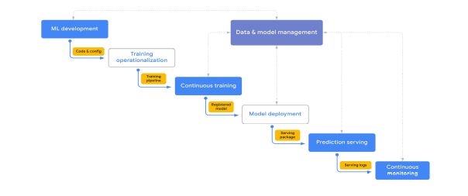

Fig. 1. MLOps process
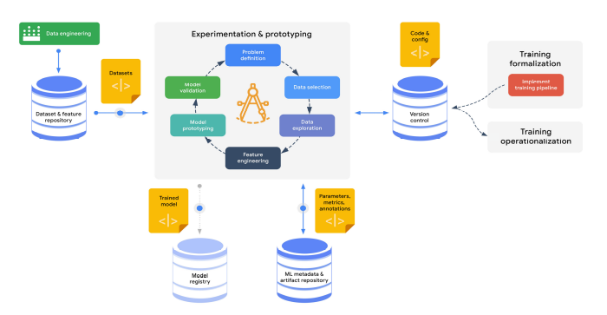
Fig. 2 ML development cycle

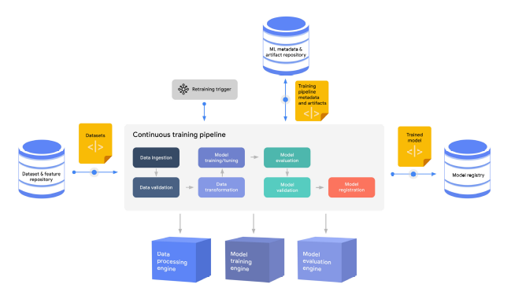
Fig. 3 continuous training process

are tracked. Successful candidates are tracked by the model management process as registered models.
- Registered models are reviewed and approved for release before being deployed to a production environment, which may involve building a custom CI/CD pipeline for delivery.
- Deployed models serve predictions, generate explanations, and capture serving logs, according to the specified deployment pattern.
- The continuous monitoring process checks for predictive effectiveness and service, including detecting model decay and monitoring efficiency metrics like latency and errors.
The ML development stage (Fig. 2) of the Machine Learning Operations (MLOps) life cycle comprises prototyping and experimenting with various model designs and training procedures. In order to control these artefacts, data scientists and machine learning researchers build labelled datasets, employ features and reusable ML artefacts, and use data and model management procedures. A defined training procedure that comprises data preparation, model architecture, and model training parameters is the main output of this phase. The training technique is operationalized
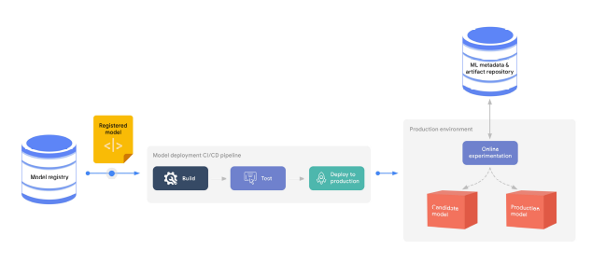

Fig. 4 Model deployment progressive delivery workflow

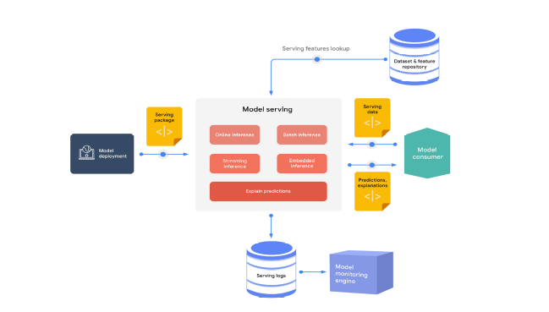

Fig. 5 Elements of the prediction serving process
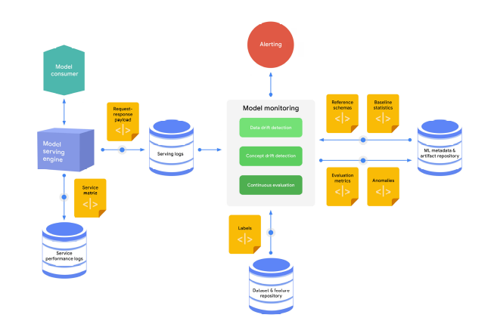
Fig. 6 The continuous monitoring process

as a training pipeline, which is constructed, tested, and delivered using a CI/CD routine, if the ML system requires ongoing training. Based on retraining triggers, the continuous training pipeline is run repeatedly to provide a model as an output. Metadata and other training artefacts are also monitored.
Figure 7 shows the flow of a canonical pipeline. Typical ML training pipelines have workflows that include to the following:
- Data ingestion. Training data is extracted from the source dataset and feature repository using filtering criteria such as the date and time of the most recent update.
- Data validation. The extracted training data is validated to make sure that the model is not trained using skewed or corrupted data.
- Data transformation. The data is split, typically into training, evaluation, and testing splits. The data is then transformed, and the features are engineered as expected by the model.
- Model training and tuning. The ML model is trained and the hyperparameters are tuned using the training and evaluation data splits to produce the best possible model.
A model is prepared for deployment once it has been trained, validated, and added to the model registry. The model is packaged, tested, and delivered to a target serving environment during the model deployment process. Similar to the operationalization of training, there may be a number of testing processes and settings involved in the model deployment process. Before being permitted to be deployed to a target environment, the model may need to go through a model governance process.
A high-level view of the model deployment procedure is presented in Figure 4.
After the model is deployed to its target environment, the prediction serving process begins, and the model service begins to accept prediction queries (providing data) and to serve responses with predictions. The components of predictive serving are shown in Figure 5. Customers may receive forecasts in the following formats from the serving engine:
• Online inference for high-frequency singleton requests (or small batches of requests) in close to real time using REST or gRPC interfaces.
• Near-real-time inference streaming, for example, using an event-processing pipeline.
• Offline batch inference, typically integrated with extract, transform, and load (ETL) procedures, for scoring large amounts of data.
• Embedded inference in edge devices or embedded systems.
A major component of MLOps is continuous monitoring, which is the process of observing the efficacy and efficiency of a model in production. It is crucial to routinely and proactively check that the performance of the model doesn't deteriorate. The properties of the serving data start to diverge from the properties data that were used to train and test the model as time goes on. Deterioration of the model's useful performance results from this. The features of the providing data may also vary as a result of modifications or failures in upstream systems that generate the prediction requests, which could result in inaccurate predictions from the model. The monitoring engine uses the inference logs to identify anomalies (skews and outliers), as shown in figure 6.
The following steps make up a typical continuous monitoring process:
1. The serving logs store receives and stores a sample of the request-response payloads.
2. The monitoring engine loads the most recent inference logs on a regular basis, creates a schema, and generates statistics for the data being served.
3. The monitoring engine compares the computed statistics to baseline statistics to find distribution skews and compares the created schema to a reference schema to find schema skews.
4. The monitoring engine analyses the serving data to assess the model's predicted effectiveness in the backwards case where the true labels (ground truth) for the labels are provided.
5. Alerts can be issued through various channels (such as email or chat) to advise the owners to investigate the model or to start a new retraining cycle if anomalies are found or if the model's performance is degrading.

Fig. 7 End-to-end MLOps workflow
After combine all of the section below, the complete MLOps workflow will look like in Fig. 7.In conclusion, the evolution of MLOps has brought about significant changes and advancements that have improved the efficiency, effectiveness, and scalability of machine learning operations. By adopting DevOps principles, integrating automation and monitoring tools, and using containerization technologies, MLOps has become a more streamlined and effective process.
- Infrastructure: The infrastructure will consist of a Kubernetes cluster running on a cloud provider such as AWS or Google Cloud. The cluster will include nodes with GPU support for running the TensorFlow Object Detection model. To ensure the system is scalable, Kubernetes Horizontal Pod Autoscaler (HPA) will be used to scale the number of nodes based on resource usage.
- Test Plan: To ensure that the system is resilient and can handle failures, a rolling update strategy will be used to replace the trained models with new ones. This will ensure that the system is always up-to-date with the latest models. A canary deployment strategy will be used to test new models in a small subset of nodes before rolling out to the rest of the cluster.
- Non-container Solution: The webapp can be built using a web framework such as Flask or Django. The model server can be implemented using TensorFlow Serving, which allows for efficient serving of TensorFlow models. The support code can be written in Python and can utilize libraries such as NumPy, OpenCV, and Pillow.
- Container Solution: The webapp, model server, and support code can be containerized using Docker. Kubernetes can be used to deploy the containers to the cluster. The containers can be stored in a container registry such as Docker Hub or Google Container Registry.
Designing an object detection system that utilizes a scalable model server with GPU support can be achieved by utilizing a Kubernetes cluster, TensorFlow Serving, and a web framework such as Flask or Django. By containerizing the webapp, model server, and support code, the system can be easily deployed to a Kubernetes cluster and scaled as needed. By implementing a rolling update strategy and canary deployment strategy, the system can be kept up to date with the latest models and resilient to failures.

References

- Y. Zhou, Y. Yu and B. Ding, "Towards MLOps: A Case Study of ML Pipeline Platform," 2020 International Conference on Artificial Intelligence and Computer Engineering (ICAICE), Beijing, China, 2020.
- G. Symeonidis, E. Nerantzis, A. Kazakis and G. A. Papakostas, "MLOps - Definitions, Tools and Challenges," 2022 IEEE 12th Annual Computing and Communication Workshop and Conference (CCWC), Las Vegas, NV, USA, 2022.
- D. A. Tamburri, "Sustainable MLOps: Trends and Challenges," 2020 22nd International Symposium on Symbolic and Numeric Algorithms for Scientific Computing (SYNASC), Timisoara, Romania, 2020
- B. M. A. Matsui and D. H. Goya, "MLOps: Five Steps to Guide its Effective Implementation," 2022 IEEE/ACM 1st International Conference on AI Engineering – Software Engineering for AI (CAIN), Pittsburgh, PA, USA, 2022.
- T. Granlund, A. Kopponen, V. Stirbu, L. Myllyaho and T. Mikkonen, "MLOps Challenges in Multi-Organization Setup: Experiences from Two Real-World Cases," 2021 IEEE/ACM 1st Workshop on AI Engineering - Software Engineering for AI (WAIN), Madrid, Spain, 2021.
- D. A. Tamburri, "Sustainable MLOps: Trends and Challenges," 2020 22nd International Symposium on Symbolic and Numeric Algorithms for Scientific Computing (SYNASC), Timisoara, Romania, 2020.
- G. Symeonidis, E. Nerantzis, A. Kazakis and G. A. Papakostas, "MLOps - Definitions, Tools and Challenges," 2022 IEEE 12th Annual Computing and Communication Workshop and Conference (CCWC), Las Vegas, NV, USA, 2022.
- N. D. R and Mohana, "Jenkins Pipelines: A Novel Approach to Machine Learning Operations (MLOps)," 2022 International Conference on Edge Computing and Applications (ICECAA), Tamilnadu, India, 2022.
- M. M. John, H. H. Olsson and J. Bosch, "Towards MLOps: A Framework and Maturity Model," 2021 47th Euromicro Conference on Software Engineering and Advanced Applications (SEAA), Palermo, Italy, 2021.
- E. Raj, D. Buffoni, M. Westerlund and K. Ahola, "Edge MLOps: An Automation Framework for AIoT Applications," 2021 IEEE International Conference on Cloud Engineering (IC2E).
- K. G. Kumaar and K. Raja, "MLOps: Practitioners guide to MLOps: A framework for continuous delivery and automation of machine learning," 2019 International Conference on Communication and Electronics Systems (ICCES), Coimbatore, India.
- R. Gomes, "MLOps: Practitioners guide to MLOps," Medium, Sep. 25, 2020. [Online]. Available: https://medium.com/@ramgomes/mlops-practitioners-guide-to-mlops-48b0e8bfc676. [Accessed: Mar. 15, 2023].
- S. Gupta and G. Garg, "MLOps: Continuous delivery and automation pipelines in machine learning," IEEE Software, vol. 38, no. 6, pp. 66-72, Nov./Dec. 2021.
- G. D. Jagtap and A. V. Kadam, "MLOps (Machine Learning Operations) Fundamentals," 2020 International Conference on Communication and Signal Processing (ICCSP), April 2020
- M. Testi, M. Ballabio, E. Frontoni, G. Iannello, S. Moccia, and P. Soda, "MLOps: A Taxonomy and a Methodology," in IEEE Access, vol. 9, pp. 44856-44875, 2021.
- Valluri, S. (2021). Machine Learning Design Patterns. O'Reilly Media.
- Len Bass, Ingo Weber and Liming Zhu, "DevOps: A software architect’s perspective", Addison-Wesley Professional, 2015.
- David Bernstein, "Containers and cloud: From lxc to docker to kubernetes", IEEE Cloud Computing, vol. 1, no. 3, pp. 81-84, 2014.
- Ekaba Bisong, "Kubeflow and Kubeflow Pipelines" in Building Machine Learning and Deep Learning Models on Google Cloud Platform, Springer, pp. 671-685, 2019.
- Announcing Git Large File Storage (LFS), 2015, [online] Available: https://github.blog.

